**PROJECT NO 19: Gold Gym**



**PROJECT NAME**

**GOLD GYM**

**SUBMITTED BY: Saransh Das (11905423)**

**Rahul Das (11905460)**

**Himanshu Pandey(11905254)**

**SUBMITTED TO: Ishan Kumar**

**LOVELY PROFESSIONAL UNIVERSITY**

**SCHOOL OF COMPUTER SCIENCE ENGINEERING**

**WHY WOULD A GYM NEED A WEBSITE??**

* A GYM website can accomplish a number of things. It can help the people stay updated with the healthy habits, attract new people and make it easy for them to contact you, or help others stay in touch and get updated on the latest health tips.
* Most importantly, it can help the fitness freaks to market themselves better by having an online presence.
* In this day and age, and it’s almost expected that your organization is on the web in some shape or form.
* Every gym website needs a news section to help visitors know what’s going on with the Gym club.

The **history of GYMs** may extend as far back as the beginnings of [military training](https://en.wikipedia.org/wiki/Military_training), with competition used as a means to determine whether individuals were fit and useful for [service](https://en.wikipedia.org/wiki/Military_service). Team sports may have developed to train and to prove the capability to fight and work together as a team (army). The [history](https://en.wikipedia.org/wiki/History) of gym can teach us about [social changes](https://en.wikipedia.org/wiki/Sociology) and about the nature of  fitness itself, as gyming seems involved in the development of basic human skills.

**OVERVIEW:**

IN THIS SYNOPSIS WE GIVE A BRIEF DESCRIPTION ABOUT OUR PROJECT WORK ON MAKING A WEBSITE FOR GOLD GYM GIVING THE INFORMATION ABOUT GYM AND GYM ASSOCIATION SYSTEM PRESENT IN IT.

OUR PROJECTS INCLUDES THE FOLLOWING MODULES:

* A PAGE FOR GOLD GYM CLUBS
* INFORMATION AND HISTORY OF GYMs
* PAGE FOR INFORMATION ABOUT THE PARTICULAR EQUIPPMENT
* INFORMATION ABOUT THE PARTICULAR EXERCISES
* REGISTRATION FOR THE PARTICULAR GOLD GYM CLUB AND HOW ONE CAN APPLY FOR THE GYM CLUB
* CURRENT EVENTS GOING ON IN THAT PARTICULAR GYM
* INFORMATION ABOUT THE TOPMOST HEALTH FREAKS, AND PROFILE OF TOPMOST TRAINERS

ROLE AND RESPONSIBILTY OF GROUP MEMBERS:

HIMANSHU PANDEY:

* INFORMATION OF GYMS
* HISTORY OF GOLD’s GYMS

SARANSH DAS:

* INFORMATION ABOUT THE PARTICULAR GYM CLUBS
* USERS REVIEWS ON PARTICULAR GYM CLUBS
* REGISTRATION FOR THE PARTICULAR GYM CLUB’s Online features
* HOW ONE CAN APPLY FOR THE PARTICULAR GYM CLUB

RAHUL KUMAR DAS:

* CURRENT EVENTS GOING ON IN THAT PARTICULAR GOLD GYM
* INFORMATION ABOUT THE TOPMOST TRAINERS
* PROFILE OF TOPMOST TRAINERS

**PROGRAMMING TO BE USED:**

* HTML(HYPER TEXT MARKUP LANGUAGE)
* CSS(CASCADING STYLE SHEETS)
* JAVASCRIPT

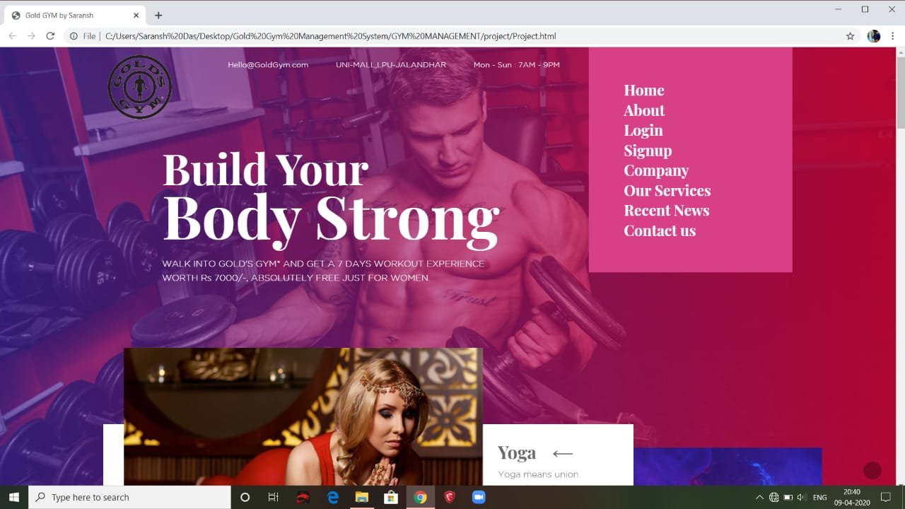

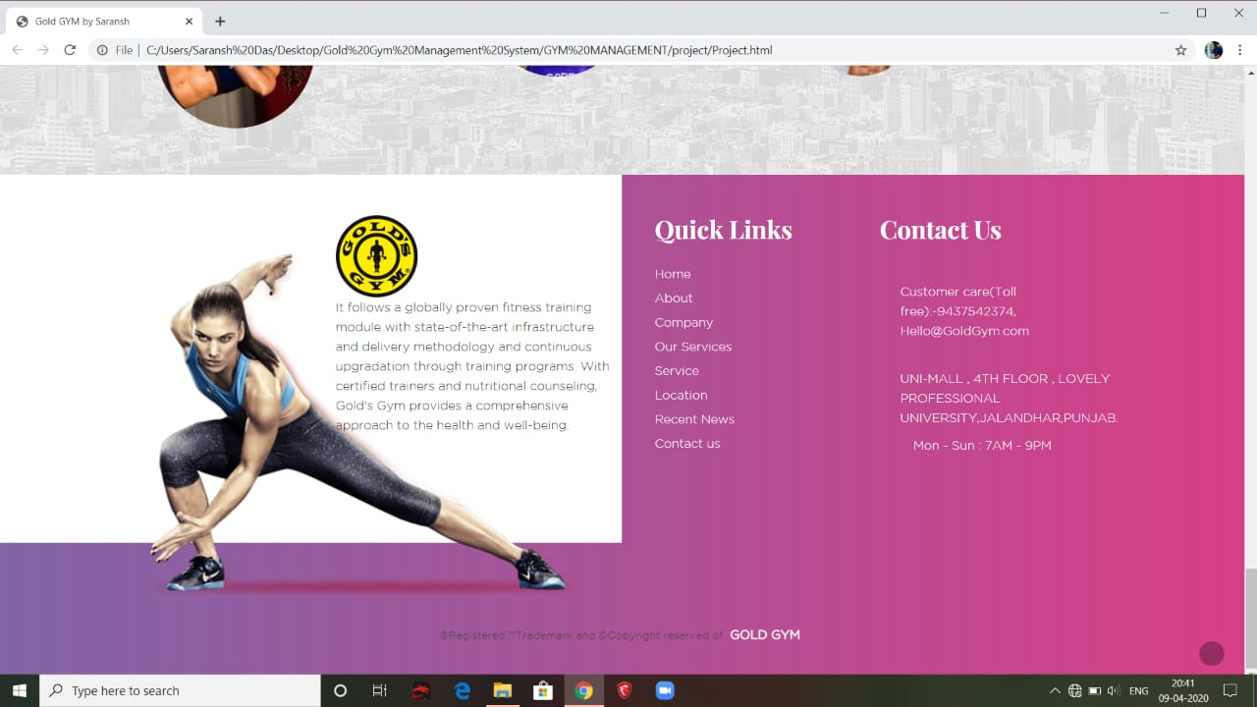

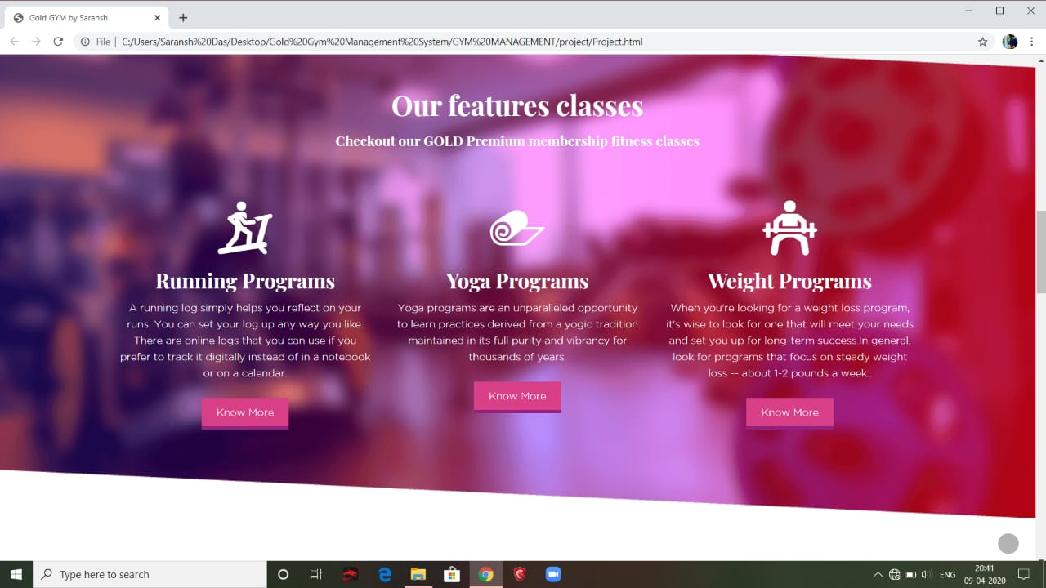

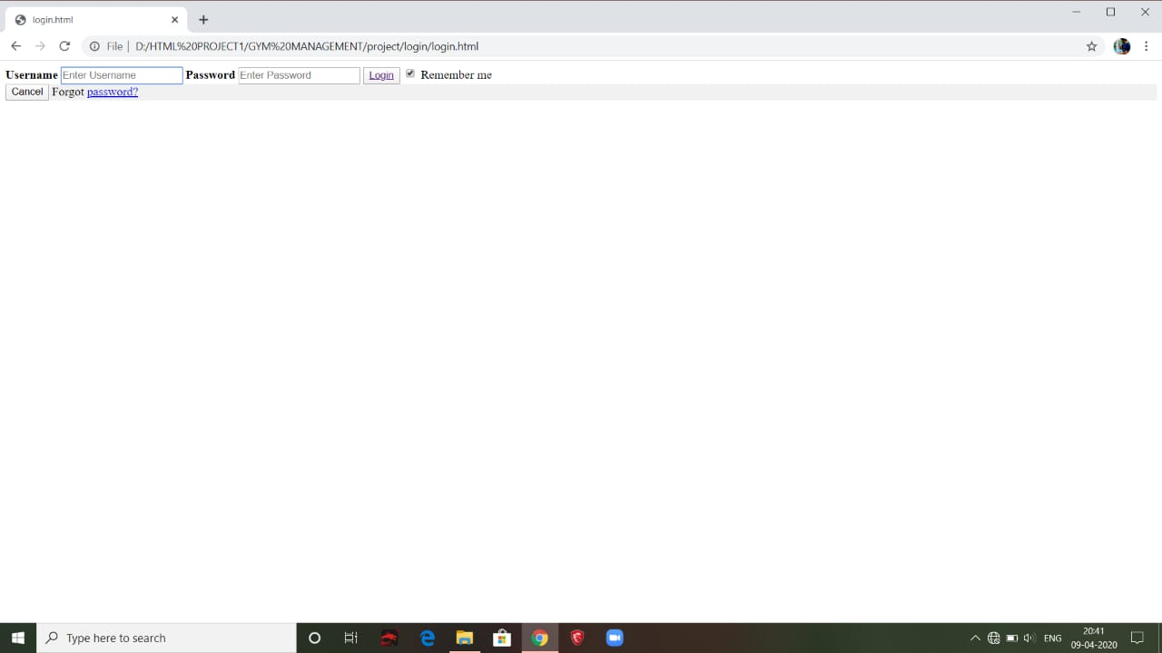

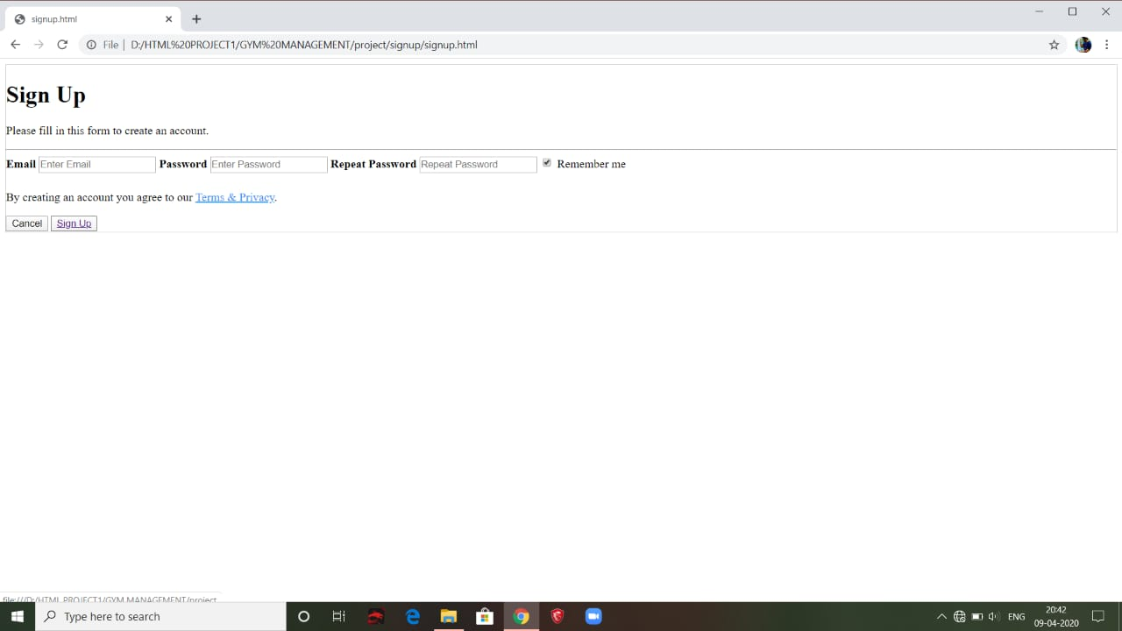

**HTML TAGS**

* **<head>……</head> Heading of html document**
* **<title>….</title> Document title**
* **<body>….</body> Body of html document**
* **<ul>….</ul> Unordered list**
* **<h1>..</h1> Heading 1**
* **<h2>..</h2> Heading 2**
* **<h3>..</h3> Heading 3**
* **<h4>..</h4> Heading 4**
* **<img>…</img> Image**
* **<p>….</p> Paragraph**
* **<a> ..</a> Anchor**
* **<li>…</li> List item**
* **<i>….</i> Italic**
* **<hr>….</hr> Horizontal rule**
* **<form>….</form> Form**
* **<div>……..</div> Section in a document**